Committee Meeting Minutes 27.07.2025

Attendance
Nicole McKinny, Bridget Ennini, Len Matthews, Norrie Louise Brown, Antony Pike Bowyer, Margaret Marsden, Sue Hotchin, Dave Proudfoot, Ann Geldart, John McAllister, Ben McAllister, Sam Lawson

Apologies
Tom Carter, Lee Grieves

Minutes from last meeting
Proposed by Ann, Seconded by Proudy

Chairpersons Report
You’ll be pleased to know that my report this time is short and sweet as there are a few items that have been added to the agenda for discussion.
Looking at Spond we’ve had six trips organised since our last meeting in May. These have been well attended and enjoyed by our club members. Thanks again to the people who have organised these – there is a lot of work involved behind the scenes to ensure that the event runs smoothly and safely.
Some members did something a bit different – heading down to Derwentwater to take up the off to practice helming a Tiger Boat! Despite the horrendous rain the evening was great fun. We even enjoyed the capsize drill – although to be honest we were already soaked and the lake water was much warmer than the rain.
Finally, don’t forget that we have the Family Fun Day on 10 August on Spond – please do keep an eye out for times & venue on Spond as these will be announced once weather conditions are known.

Finance Report
There is some movement in the current account with new memberships and the sale and purchase of equipment, but accounts are looking good. We should also soon receive £60 from Norrie work as a donation for us hosting their taster day.
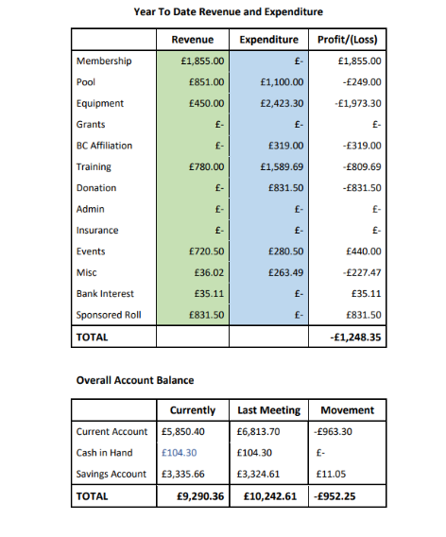

Welfare Report
The Disclosure and Barring Service (DBS) check for Lee has now been completed. We have transitioned to a new system for logging DBS checks. I kindly request your patience as I familiarise myself with this new process. Should anyone require a DBS check on an urgent basis, please do not hesitate to inform me, and I will make every effort to facilitate the request promptly.
Just a reminder about the update service. Please find the link below to verify your status on the Update Service. Upon logging in, the information will be available on the homepage.
If you are not enrolled in the Update Service, I kindly request that you contact me at your earliest convenience with the expiry date of your current Disclosure and Barring Service (DBS) certificate, so that I can initiate the process for a new DBS application.

Equipment Report
Stocktake complete, thanks to Len, Tom and Anthony for the help. Thanks also to everyone who brought back kit they had kept safe.
We are still missing BA’s 1(Small), 6(small), 12(large) & 14 (XL) and Paddle 52 (black Streamlyte), if anyone still has these please let us know.
We’ve had some neoprene decks donated for club members to use, these are kept near the paddles on hooks, various waist sizes and cockpit sizes.
Stock take has highlighted a few maintenance issues, A reminder to those borrowing kit to look after kit please & notify a coach / leader of any faults, several sea kayaks are out of action due to unreported issues.
Bought 5 replacement canoe paddles & various airbags to replace old worn-out ones.
I’ve shortened one of the Streamlyte paddles to 194cm for smaller adult paddlers, I will shorten 3 more to 197cm to give us a broader range of paddle sizes for members.
Following the development plan to have modern shaped kayaks to assist in teaching newer methods we’ve moved some of the older less used boats to the pool, and are selling the older pool boats & boats that are no longer current. Anthony has donated some play boats to the club, some of which have gone to the pool.
The more modernised fleet consists of these new (to us) whitewater boats:
Small wave sport Diesel
Medium Jackson Karma
Large Jackson Zen
Dragorossi Fish (Playboat)
A Small Jackson Zen is in the pipeline when a few of the others have been sold
We have sold the 2 oldest sea kayaks, as they were obsolete. Replaced by 2 newer ones sourced from Tony Colla.
We have also sold one of the old Kendo’s to a member of Penrith polo club.
We also have for sale:
microbat 230
Microbat 250
Microbat 250
h3 245 yellow
prijon chopper
Prijon kompressor
Kendo yellow
Kendo red

John asks – is it work making a list or picture diagram of what to look for when borrowing / using kit on what to report if it isn’t there or if it is broken? Proudy will look into this.

Coaching Report
Coaching has gone well; all nights have been covered. Trips have been well led and well received. As we head into winter, we hope to see the trips continue and the arrival of more water encourage more white water trips. We have seen a very positive retention from our beginners’ sessions.

Membership Report
We have seen a nice increase in membership since last meeting going from 48 to 67 mostly thanks to our beginners’ sessions. Len has booked a table at this years freshers week at the university on the 16ths of September. We will need Flyers, laminated pictures, and QR codes of the website sign up page.

Equality, Diversity and Inclusion
Nothing to report

Upcoming Events
All booked in upcoming events are on Spond. Introduction to whitewater needs dates booked in, Antony to send dates to Nicole.
Can Nicole email Cumbria Canoeist regarding the Jim Wilson Memorial Paddle on the 27th of September.
Norrie has emailed Derwentwater Marina to thank them for a very enjoyable session helming the Tiger boat and if it would be possible to have more use of it in the future and how much donation we couple put towards its up keep for using it.

Document reviews and Audits
Nothing to report, please everyone keep an eye on your relevant documentation

Development Plan/Accreditation/Quality Club Status
Nothing to report

Risk Register Review
Nothing to report

Club Funded Courses
Proposal: that the club cover costs of key courses required by coaches/leaders to keep their qualifications in date.
Decision: Agreed - that First Aid and Safeguarding courses to keep active coaches and leader qualifications in date will be financially supported by the club. For those coaches and leaders that provide support utilising their qualifications only to the club, costs will be fully funded. Those that utilise their qualifications for organisations other than the club, funding will be proportionate to the balance of commitment.
John McAllister to provide details of Rescue Team First Aid trainer to Antony, as head coach, to confirm details and coordinate future activity with support from committee members are required.
Agreed: new individuals developing coaching/leadership to be assessed by the club on a case-by-case basis

Proposal: that registration costs for instructor/coaching and leader courses be included as part of the overall cost of a course. Decision: Agreed

These decisions are to be added to the key decisions register by Nicole.

Matters arising from last meeting minutes (in so far as not covered above)
None

Pool
Proudy is going down to the pool to swap some boats out and do some maintenance he is happy to ask the pool how the would like to proceed this year with pool sessions this year. Following the pool response we need to assess whether we can regain use of personal boats. We also need more members feed back of what they want from pool session to tailor pool session to get better attendance.

Email from John Soady re Cumbria Canoeist
Ann will attend the virtual meeting on behalf of Carlisle Canoe Club and report back at next committee meeting. Nicole will email john to let him know and pass on Ann email address for the e-invite to the meeting.

Any other business
None

Date and time of next meeting
30th of September at the Sands at 21.15

