Committee Meeting Minutes 21.01.25

Attendance
Nicole Mckinny, Lee Grieve, Bridget Ennini, Margaret Marsden, Ann Geldart, Antony Pike-Bowyer, David Proudfoot, Len Matthews, Ben McAllister, John McAllister

Apologies
Tom Carter

Minutes from previous meeting
Proposed by Ann seconded by Margaret

Chairpersons Report – Bridget
Welcome to 2025!
Since the AGM both Jasmine & Proudy have passed their White Water Leader Assessments. Congratulations to them both! This puts the club in a good position for 2025 events.
We also have a number of other members who are working towards their assessments and I’d like to wish them all the best for these.
Over the course of the last couple of months there has been a decent amount of paddling, including trips as well as the Saturday river sessions at the Sands. This is great to see.
The Christmas lake and river paddles were well attended, and from what I’ve heard were very enjoyable. Thank you to the organisers – I know a lot of work goes into planning these events.
Pool sessions on a Thursday evening have been pretty quiet. Whilst this has provided ample space in the water for people to develop skills it does mean that we are sometimes not covering the cost of the pool hire. I’m keen to hear from members the reasons why attendance has dropped from previous years to we can explore solutions.
Finally, I have a shout out to anyone who is interested in taking on the role of Chairperson in November. This is my third year in the position which means I do need to stand down at the next AGM. If you are interested, please have a chat with me to find out more about what is involved. I’d ideally like it if someone could ‘shadow’ me this year so that they can gain experience.

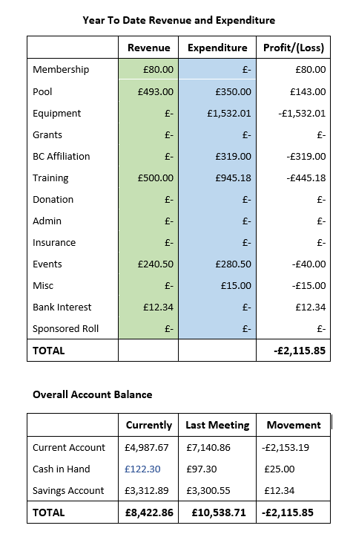
Finance Report – Lee
Points of interest since start of financial year (1st Oct):
Savings Account - £3312.89 this is up £12.34 due to an interest payment
Current Account - £4987.67 this is down £2153.19 due to -
£319.00 Paddle UK Affiliation
£445.18 club contribution to first aid training
£1532.01 Equipment - purchase of 2 sea kayaks from Tony.
£132.01 Outfit of container.
£40 Launch fee for lake paddle.

Pool Sessions
Currently taken in £493.00, however awaiting invoice for Dec/Jan of approx. £350.
This will put us at a loss of £207.00 up to now for the pool sessions.
After Oct/Nov invoice we were down £69.00

Welfare Report – Ben
Nothing major to report. I went on a conference with Active Cumbria, this was really interesting and useful, and have another in February, there possibly may be more training for coaches following this. Thank you to those coaches who have filled in all relevant paperwork, any who haven’t by next meeting will be suspended from coaching.

Equipment Report – Proudy
2 new airbags have been bought, nothing else currently to report, it’s not the time of year to be selling the boats we would like to sell yet. Again, I would like to remind all members that if something breaks in a boat, please just message me so I know to fix it.

Coaching Report – Antony
We have had 2 people pass their white water leader assessment. Saturdays have been well covered by coaches, although numbers of participants have been low. To note that trips on Spond have also had very little responses.

Membership Report – Norrie
Current membership is at 93. We look forward to welcoming more beginners come spring and being back on the river. We are still looking into the sandwich board advertising for the side of the river. Action- Proudy is sorting this.

Equality, Diversity, and Inclusion Report – Ann
Nothing to report.

Upcoming events
Proudy is going to try and do one trip a month. Norrie has a grade1/2 trip booked for the 15th of Feb. We do not organize many trip for a Sunday so maybe we should try and target some Sundays to see what turn out is like.

Document Reviews
Norrie has made a start on looking through the welcome pack. We do still need a container risk assessment by John. Tom also needs to know about updated risk assessments.

Development Plan/Accreditation/Quality Club Status
Everything that needs done is to do with the club house which can’t be accessed right now so its on hold.

Risk Register
All is up to date

Matters arising from last meeting minutes
The council are looking at upgrading river access and egress, we are unsure how long it will take.
Should we add more awards to our AGM, for example - per age group awards or coach of the year. Can we all go away and have a think about it and we can discuss it next committee meeting.
Regarding insurance discussions around the container, it is not possible to put insurance on it. Therefore, no further action with insurance until we are looking at moving back into the club house.
The club trailer is to go up for sale, Nicole will discuss this with Tom for maybe some better pictures and organizing the sale, committee recommend advertising it for £600 and seeing what kind of interest we get.

Any Other Business
Can we ask if we have any updated rough date for getting back in the club house even for a look, then we can start planning the refit before moving our kit back in. Can Bridget ask Cubbys for any updated timeline, and whether we can get in for a look, and start refit work sooner than when we loose container and have to move everything in.
Sponsored roll posts had two nominations for charities – North Cumbria search and rescue and Sunbeams music trust. Committee decided to split to proceeds 50/50 between the two. Nicole to announce this on club pages to members and to organise the distribution of sponsored roll forms.
The club logo we are using is still the anniversary logo. John is going to find the logo which does not have the anniversary text on it and distribute it so it can be changed over.
Discussion was had in reference to Paddle Uk rolling out a revised suite of white water safety courses after a review of the practical needs of paddlers. In particular the Introduction to White Water Safety (IWWS) course. The IWWS course was designed for paddlers starting their white water paddling journey and exploring the grade 2/3 (moderate) river environment. It provides knowledge and skills needed to be a safe and useful team member. This led to discussions on whether the club requires members to attend the course, or to have the knowledge and self rescue skills equivalent to the syllabus of the course, to be the pre requisite safety requirement prior to members attending club organised 2/3 river trips. It was agreed that members should have the knowledge and self rescue skills equivalent to the syllabus of the IWWS course prior to attending club organised 2/3 river trips. If the course has not been attended, they should be willing to demonstrate their abilities if requested by the trip leader. It was felt important to clarify to members that this is not being introduced as a hurdle to the them attending river trips but as a way of ensuring theirs, and their fellow paddlers, safety on the water. It was also agreed that the club would support members with their training to attain the required knowledge and skills.

Next Meeting
Next committee meeting will be on the 1st of April 2025 at The sands.

