Committee Meeting Minutes 27.05.2025

Attendance
Tom Carter, Lee Grieves, Antony Pike Bowyer, Len Matthews, Chloe Thomson, John Mcallister, Norrie Brown, Ben Mcallister, David Proudfoot, Ann Geldart, Scott Pollendine, Bridget Ennini.

Apologies
Margaret Marsden.

Minutes of Last Meeting
Proposed by Ann, Seconded by Lee

Chairpersons Report - Bridget
Well so far this season we have seen an unprecedented lack of rainfall resulting in incredibly low river levels! It’s a double-edged sword in that whilst we all love a bit of sunshine; we do need wet weather to happen to keep the rivers paddle-able. Whilst the weather has restricted the variety of paddling, we have been able to I know a number of our members have been out & about, navigating the rockier stretches and no doubt gaining some skills during this process as they learn to look out for new obstacles.
Notable events that have happened so far have been as follows:
- White Water Safety sessions – the first session of this was fully attended and I’ve heard that it was enjoyable and participants learned a lot. Watch out for future events during the course of the year (when the rivers get more water in them)
- Tiger Boat Race – a good turnout (would be great to field two teams next year)
- Wavehopper race – A great day down on the sands with participates arriving from all over the country competing in C1, C2, K1 and K2. Brilliant to see 3 of our own members - Sonny, Margaret and Lucas not just competing but collecting some medals too!
and great fun for both participants and supporters. The event see’s teams from a range of clubs across Cumbria pitching themselves against each other in ‘tiger-boats’ – think very large open boats that hold 10 paddlers, a drummer and a helmsman (who steers).
As always thanks again to all the people who have been organising paddle events for our summer season. I know how much these are appreciated and enjoyed by our members.
Finally, at the last meeting I advised that I was trying to get answers on how long the club house would be out of action whilst the RAAC is being removed from the Sands Centre and the roof structure is replaced. As you will be aware Len & I had a successful with the Council & Cubby Construction resulting in agreement for pedestrian access to our clubhouse area on Tuesday/Thursday evenings to obtain kit and use changing rooms. I have now agreed with the Council/Cubby’s that we can have access at weekends subject to the same requirements (i.e. restricted area and no vehicular access) for collection/return of equipment where paddling events have been arranged.
Note: the changing rooms have been swopped around, with the ladies now on the left-hand side (the larger area directly opposite the main door) and the men’s on the right hand side (smaller area) reflecting the increased number of women using the facilities.

Finance Report – Lee
There has been no movement in the savings account which remains at £3324.61.
The community account has increased by £1453.03 since our last meeting, thanks to membership/ taster session payments and the sale of the trailer. Account now stands at £6813.70.
Membership - Membership payments amount to £1365.00 up to now. This is slightly down on the previous 3 years.
23/05/2024 was -£1760 (-£395)
23/05/2023 was -£2015 (-£650)
23/05/2022 was - £1849 (-£484)
There have been 34 renewals, 9 taster sessions and 3 new members.
Training - The White-water Safety Intro course which recently ran cost the club £320, with members contributing £280.
Club Refurb - £750 was set aside for the refurb project which has started with £227.47 being spent. £522.53 remains to continue the project.
Sponsored Roll - The sponsored roll has raised £831.50. This means that each of the nominated charities will receive £415.75. Can I get confirmation of the account details for Sunbeams Music Trust and North Cumbria Search and Rescue so I can forward them the money. Action - John and Nicole to confirm bank details of the charities.
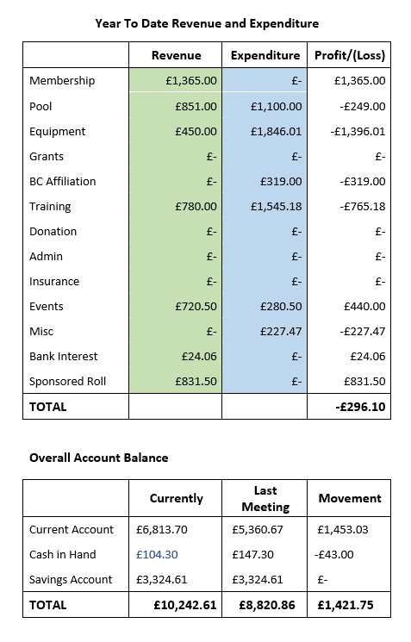

Welfare Report – Ben
Lee your DBS is nearly complete.
DBS service provider “First Advantage” are moving the platform used to process DBS check from the current online disclosures system to a new system called “Know Your People”. As part of this change within Paddle UK, we will be required to move the information over.
Club DBS Verifiers will still have access to the Online Disclosures system to process DBS applications until Saturday the 31st of the May. However, from Sunday the 1st of June all new DBS checks will need to be processed on Know Your People.

Equipment Report – Proudy
We have 6 new spray decks. There are a few bits of outstanding kit that hasn’t been returned since we had to clear the club house, again this is a shout of for anyone with any club kit at home to please let us know what you have and when you intend to return it please. Stock check is due and will be starting soon, this has been delayed due to the issues of access and kit being spit across people’s homes, the container and the club house.
Thanks go to Andy, Len and Tom for their help with the boat store renovations to date. Any ideas on what else to do with the boat store and club house renovations please talk to Proudy. Action – Nicole to put a message on social media asking for suggestions on renovations
Len – We still seem to be short on Small/ Medium PDFs. Proudy – We will recalculate after stock check about maybe purchasing more.

Coaching Report – Antony
Tuesdays and Thursday evening session have been covered by a duty coach; they have also been made the host on Spond for their relevant sessions so members know who is the duty coach. Tuesday sessions have been well attended and have a great variety of craft and skill levels; Thursdays are not as well attended. Beginners’ sessions have started and the SUP session we ran was well attended and went well.

Membership Report – Norrie
We haven’t seen a large number of memberships this year, we have around 50. Action – Norrie will contact previous members whop have not renewed to ask if they would like to share their reasons, so we can see if we have some things to improve upon / change. Len proposes we separate the beginners’ sessions costs from the membership instead of their £10 fee being deducted from the membership costs. Norrie seconded. Committee vote – all for, none against. This will be put into action for the next intake of beginners Action - This will need updated on club website and starter pack by Tom and Norrie, Nicole will update key decisions register within the one drive.

Equality, Diversity and Inclusion – Ann
Nothing to report.

Upcoming Events and Trips
As well as our usual Tuesday and Thursday sessions we currently have booked:
29th of June - lake or grade 1-2 river trip
5th of July – whitewater trip grade 2-3
13th of July – lake or grade 1-2 river trip
10th of August – family fun day lake paddle
Tom is also looking at adding some trips into the Spond calendar soon.

Document Reviews and Audits
Thank you to Norrie who has totally refreshed our welcome pack.

Development Plan, Accreditation, and Quality Club Status
We are accredited and gained our quality club status again. Thank you again to Norrie for sorting everything needed for that.

Risk Register
Action – everyone to review their relevant parts please.

Spond
Len proposes that we turn on notifications for everyone, this will affect anyone who joins after the change. We will then publish instructions on how members can personalise their own push notification settings to their preference. All committee members are in agreement.
Action – Ann to change Spond push notification settings and John to publish video instructions

Matters Arising from Previous Meeting
None

Any Other Business
Len would like to add an agenda item to the next committee meeting which is: To have a look at what courses the club helps / totally funds for which members / coaches / leaders. Action – Nicole to add to next agenda.

Bridget would like to propose moving the date of the AGM as she now has a holiday commitment on that date. It isn’t yet in the Spond calendar so hopefully should affect too many people and as its her last one as chair she would really like to be in attendance. Proposed new date is 2nd of December – all in agreement. Action – Date added to Spond calendar by Ann.

John highlights that some risk assessments need changed due to some named people no longer being involved with the club. Action – John to change risk assessments, can everyone please read risk assessments that are relevant to them.

John would like to know where to find the list of coaches and leaders with their relevant qualifications and the certification expiries – Can be found on the Paddle UK portal.

Signing on and off the river has been stopped on the website it is now just a form to log the borrowing of kit. The duty coach of the session is to account for everyone being off the water with however they see fit. This will need changed in the standard operation procedures. Action – John to change this within the SOP documents.

John highlights that the website still needs some updating to fit with the change from British Canoeing to Paddle UK, mostly updating links. Action – Tom to go through website and update what needs updating.
Norrie says he has had a great response with regards to his tiger boat helm training post he made, and would like to book in dates. Action – Norrie to liaise with Derwentwater Marina to organise dates.

Date of next meeting is the 29th of July and 2015 at The Sands.

