Committee Meeting – 30.07.24 – The Sands

Attendance
Nicole, Tom, Len, Bridget, Ben, John, Sam, Scott, Ann, Rosie, Norrie, Benjamin, Margaret, Harvey and Joe

Apologies
Proudy and Antony

Minutes from previous meeting
Minutes proposed by Ben, seconded by Ann.

Chairpersons Report - Bridget
Firstly, I’d like to pass on thanks on behalf of the club to Tony Colla who has recently decided to hang up his paddling kit. Tony has dedicated a number of years to the club both as a respected committee member and as an instructor, helping train newcomers to the sport. I’d like to wish him well for the future and extend an open invitation to all our shore-based activities.
I would also like to take this opportunity to formally congratulate Tom Carter, Ben Staddon and Joe Rimmer on qualifying as Paddlesport Instructors – well done guys on becoming the next generation of instructors in the club.
Since the summers season started, we’ve had a number of new starters join the club. They have been progressing their skills development via the new structured approach which culminated in a river trip from the Sands to Cargo for a number of the first cohort to complete the four-week programme. This was followed up by a slightly longer trip down to Rockcliffe for a number of club members. This provided experience of paddling a different section of river, awareness of hazards and understanding of signals that may be used when paddling to direct the group. Thanks to Norrie Brown for organising and leading these trips.
Our Summer BBQ took place on 16 July. Despite the poor weather so far this summer the sun held out and we had a great evening of paddling followed by the BBQ. It was lovely to see such a large turnout of members. Thanks go to all the chefs for cooking everyone’s food.
Looking ahead - we have a couple more events coming up over the summer that I’d like to remind people about. Our Family Fun Day is on Sunday 18 August – please keep an eye out on Spond & Facebook for updates as we get nearer the time. We also have the annual Jim Wilson Memorial Paddle at 10:00 on Sunday 22 September at Glencoyne Bay, Ullswater. And finally with regard to events paddling during the weekday evenings will come to a close on Tuesday 24 September with the evening’s paddling culminating in a BBQ (weather permitting of course)!
The Thursday evening pool sessions will then start from Thursday 3 October at 20:15 (Trinity School Pool).
I’d like to end my report with a shout out to any budding Treasurers in the club. Len will be standing down at this year’s AGM (26 November) having completed a 3-year term. We are actively looking for someone to take over the role so please do speak with Len if you are interested and want to know more about what is involved. It’s a great opportunity to become involved in the running of our club.

Finance Report – Len
Current Account- £6943.65
Savings Account -£3288.25 - interest £12.25
Majority of activity has been Membership and Taster Sessions
Equipment: £30 payment made for BA testing
Donations: A number of donations received from the sale of donated kit that were not on the inventory - Paddle, PFD and Spray deck - totalled £150
General Points: I have spoken to Antony reference training for bank-based members, he will look into it.
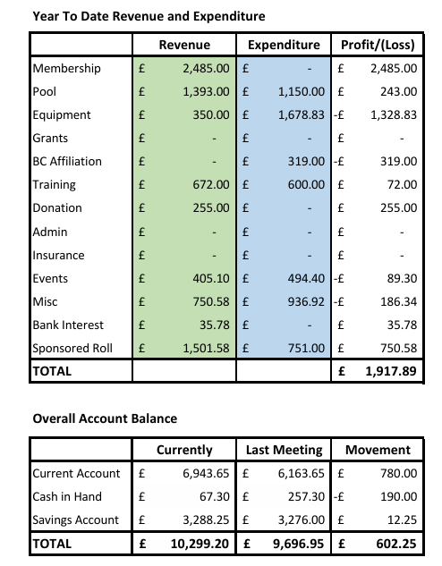

Welfare Officers report – Ben
Still awaiting some coach update forms
• Antony pike Bowyer
• Mark Johnston
• Scott Pollendine
I have received
• Jim Winterton
• Norrie brown
• Len Matthews
• Proudy Carlisle
• John McAllister
Still waiting for some recruitment forms
• Chloe Thomson
• Benjamin Staddon
• Johnathan Pagan
Safeguarding training link https://paddleuk.org.uk/safeguarding-training/

Still waiting for Joe and Lois to send me the DBS information and these need to be done ASAP as time will run out and will have to start the process again.

If you are unsure, please message Ben (or Norrie if you are unsure whether you need to revalidate any of your training) Bens club email is: cccwelfare@outlook.com

Equipment Officers report – Proudy
We've needed to replace some broken canoe paddles, a new One is on order from Ant, one has been repaired, one more to be made from an old paddle.
Couple of ongoing repairs to fleet, nothing major.
Need to reiterate to users that faults need to be reported so they can be fixed, not just put away.
Also, a reminder to keyholders at the clubhouse at the end of session that kit needs to be rinsed off when being returned to clubhouse, several boats covered in sand again last week.
Sea boats: we’ve been offered 2 fairly modern boats, in good order from Tony Colla.
I propose that (pending inspection by myself and Norrie) we’d plan to sell the original p&h that’s serviceable but we can’t get parts for, and replace that and the scrapped one with Tonys 2, Estimated cost £650 each.
(Good value, 2nd hand they’re going for 800+)
Needs a vote – All members present voted unanimously for this.

Coaching report – Antony
Good numbers of coaches and instructors helping with the sessions on a Tuesday night and cover on Thursday rota seems to be working when I remember to do it on time.
The addition of the river trip to the end of the beginner sessions has been well received and has carried the skills learnt over to a trip environment. Thank you, Norrie, for running these trips.
We have three new paddlesport instructors to add to our ranks Benjamin, Tom, and Joe. Hopefully they will be shadowing the beginner sessions to build up some knowledge and help out on the sessions.
Deployment of the paddlesport instructors will be clarified as to where they can instruct and what additional awards / training they need to be deployed.
I have arranged a first aid course for the coaches / leaders that need updates. This will be at Talkin Tarn on the 19th & 20tj of October more details to follow shortly.

Membership – Norrie
Current number of members
Family memberships up 5 to 15 with registered family members up 8 to 35 (26 Adults, 9 Youths)
Youth memberships (Sonny, Cameron, Hayden PR) remain at 3
Adult memberships up 6 to 39
Honorary Lifetime memberships remain static at 3 (Walter, Rae, Tony)
Total Adults 39+26+3=68
Total Youths 9+3=12
Total members =80 up 14 from 66
Circa 129 at affiliation last year

I have added Antony to conflict of interest register due to Head Coach Position and Paddlesport related business. Managed through the Committee as appropriate.

Question: Would the committee support a session on the river for a small number of people from the inclusive swim group? Probably open canoes. Yes of course, full support given.

ED&I report – Ann
I have been working through the recommendations from the Quality Club document from 2023 and the current #WePaddleTogether ED&I strategy from Paddle UK. Looking toward the next Quality Club assessment there are a number of suggestions that should raise the club’s scores in particular areas that could addressed over the next few months. These are:
Updating the photographs that are on the canoe club website. Photographs on Facebook reflect well the activities of the club and the diversity of its members, but the most recent on the website are from 2021. Tom checked that photo permission is given at the time of signing up for our beginner’s sessions. Tom will update website photos using ones from the Facebook group. John and Joe to look at updating public facing Facebook page – Nicole offered to help if given access to it.
Members who are coaches, instructors, leaders and guides and committee members completing Paddle UK’s online training for Disability Awareness and Equality, Diversity and Inclusion. A register could be posted on the shared drive for people to record when completed.
Paddle UK will be requiring all members to complete an ED&I monitoring form from the end of the year, is this something we want to do as a club to show we are proactive in this area. There would be the need to maintain member confidentiality – maybe use something like survey monkey to ensure anonymity. Tom will look into google form or the likes for this.
Paddle UK are looking to promote all forms of paddling to a wider audience. Would it be useful to have a promotional flyer/poster to showcase the canoe club in the event we feel we are in a position to actively promote the club to increase membership.
As a part of #WePaddleTogether ED&I strategy would it be possible to canvas the female members to see if there is any interest in an all-ladies paddle sometime, embracing #ShePaddles strategy. And possibly encourage more ladies to become coaches, instructors, leaders or guides. If any members would like this please come forward. If not enough come forward for us to run our own we can direct them over to Cumbria canoeists and we can advertise Cumbria Canoeists all ladies paddle when they post it.

Upcoming events and trips
Family fun day 18th of August venue Ullswater Glencoyne. More details to follow on Facebook and Spond.
Next years trips to be added to the next meeting’s agenda.

Due to running out of time at our venue the rest of the meeting was condensed to just the immediately important items.

Any other business
Tom would like to make slight changed to the online form regarding borrowing kit and the length of time it can be borrowed. Everyone is happy for him to go ahead with this.

John McAllister would like to remind club members that if anybody would like to give slalom a go he is happy to put out the gates.

Sam has attended to discuss our club kit insurance with us. Currently boats taken and used not on an official club trip are not insured. Personal kit kept at the club house is insured. Currently our insurance covers £8000 for personal kit, and £25000 for club kit. We would like Sam to please get a quote for swapping this that personal kit is not covered but club kit used for non-club activity is covered. Once Sam has spoken to the brokers and got some figures we can action a separate insurance meeting. Thank you Sam.

2024 winter pool sessions are under review as to how they are to be ran and will be briefed out as soon as finalised.

Our next meeting with be at 18.30 on Thursday the 26th of September at The Sands.

